Asia-China-Coin-Round-H 6.26

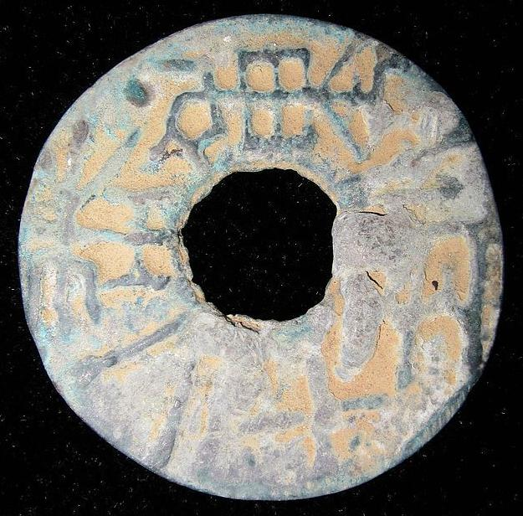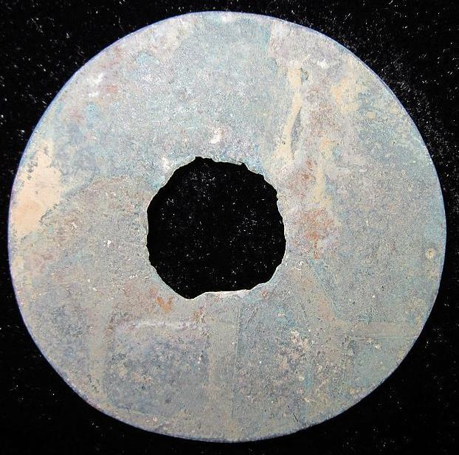

Coin, Round shape with a Square hole, life tool. It plays an very important part in Chinese history. It had been used since the Qin Nation in early Spring and Autumn Period.Such a long time.People use it to get things they need, government use it to steady their rule...

重一两十二珠,Also called"珠重一两十二",Round coin which was made & used in the Qin Nation, Middle & Late Warring states period."珠"means coin,"重一两" weight, "十二" marks year or number.

This collection is a very rare Bronze Round Coin.

NAME:重一两十二珠

SORT:Coin,Life tool

MATERIAL:Bronze

LENGTH:3.4CM/1.34Inches